switch block won't support all the data types that the if block supports

**Fall though when it comes to switch block,**

if there is no break statement java will also check for the cases below even if it found the case one matching.

So as a result; the default block within the switch block will always run if not to the break statement.

This is called fall though when it comes to the switch statement…

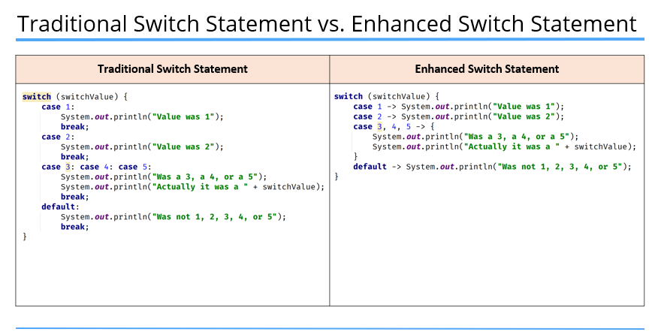

realize that there is no need of the break when we use the modern switch

We could also use the return statement instead of the break if we are in a method in traditional switch statement

If we have to return a value we could use the "yield" keyword

and always mind that it should be contained within curly braces or it would rise an error.

The for loop

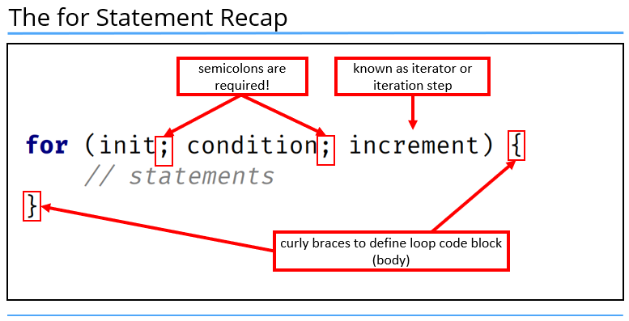

Here is a special case when it comes to the usage of the for loop…

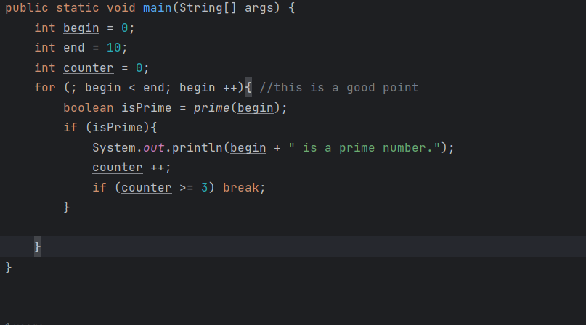

The while loop

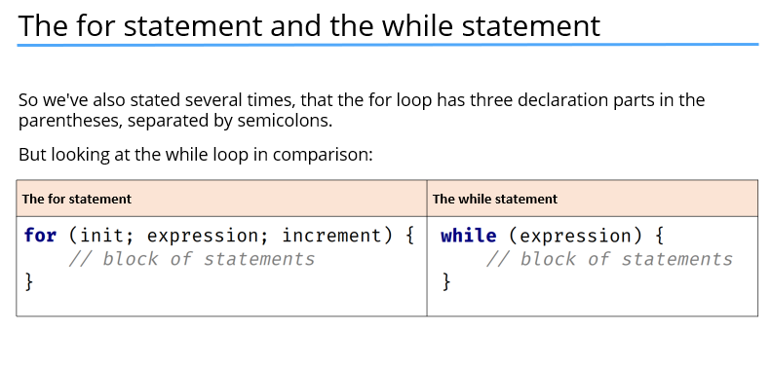

Loop controls

**break;**

Use to terminate the loop…

**continue;**

Use let the java know that code lines below the continue should not get executed and the loop should start over starting with the next increment.

It’s always recommended that we create the necessary variables right in side the same scope we use then if we do not plan to use them out of the same scope…

Conversion between data types

You may use the following format for this..

* <Wrapperclass>.parse<data type With first letter capital>(<the data that should be converted>);

Exception handling

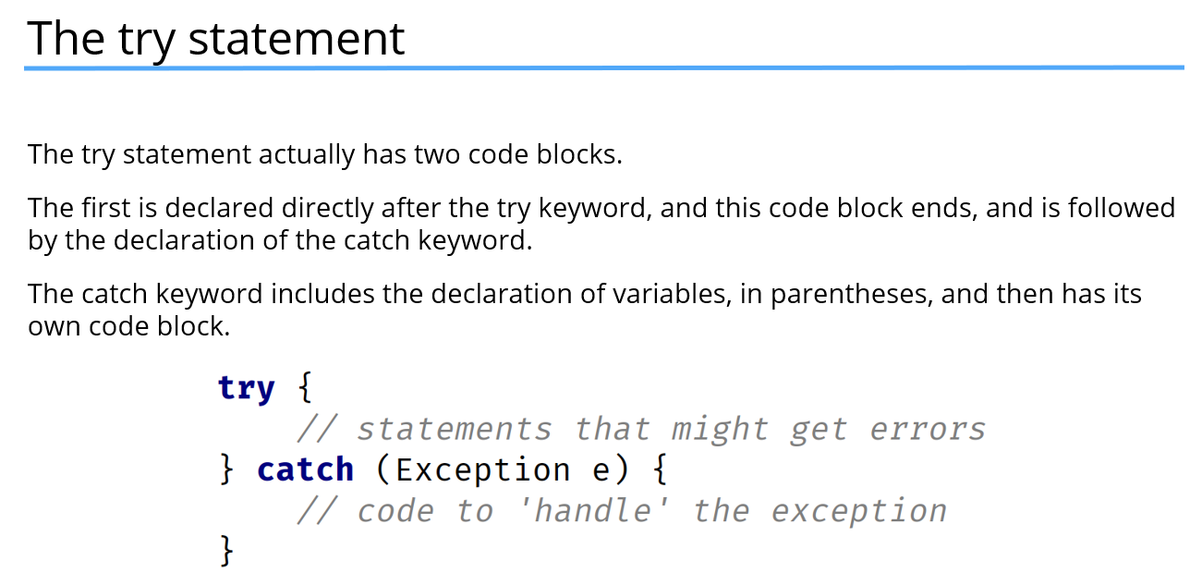

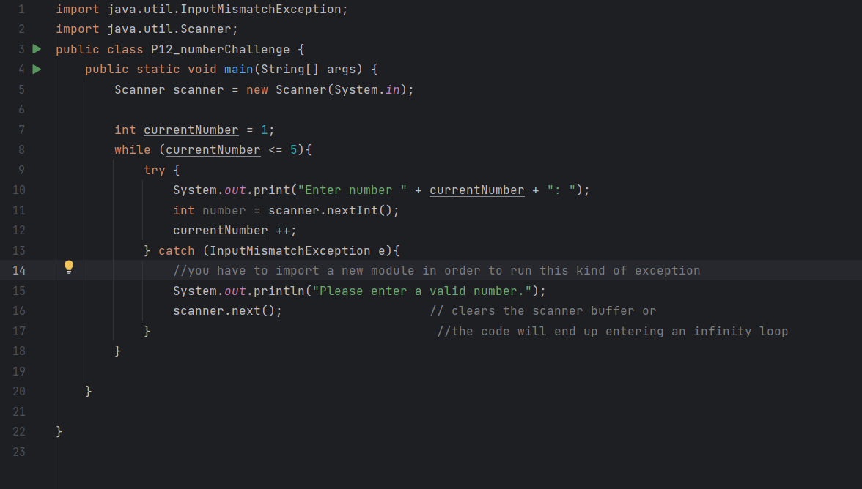

Mind that in many of the cases you wont need to import the exception  
show above is just an instance where you need to do so…

